TOURISM WITHIN THE DIFFERENT PROVINCES

Province | Percentage
Limpopo | 20.8
Gauteng | 13.6
North West | 7.9
Nothern Cape | 2.4
Western Cape | 10.4
Free State | 6.5
Eastern Cape | 13.5
Mpumalanga | 10.1
KwaZulu-Natal
Total | 100
Table 1 : Percentage contribution per province

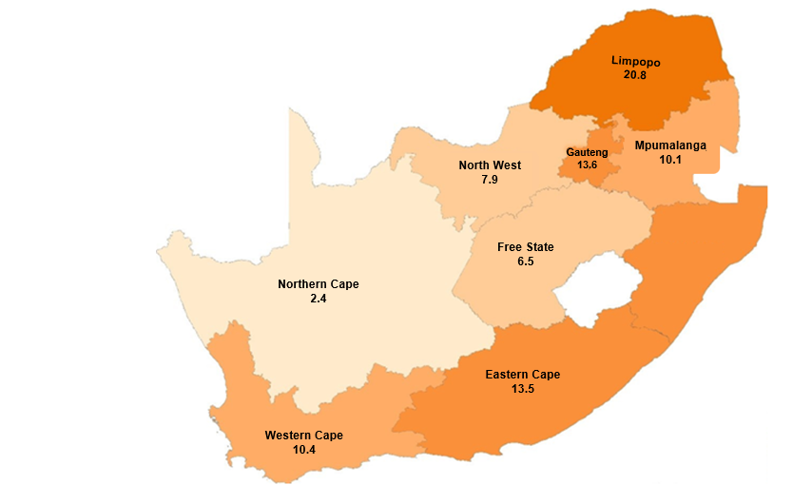
KwaZulu-Natal
??

